**The Ark Documentation.**

**Data Set Definition function.**

Log in and select your study by clicking the hyperlink corresponding to the name of your study.

Once you have chosen your study we will be able to adjust study details or select modules and functions available in that study (for which you have privileges).

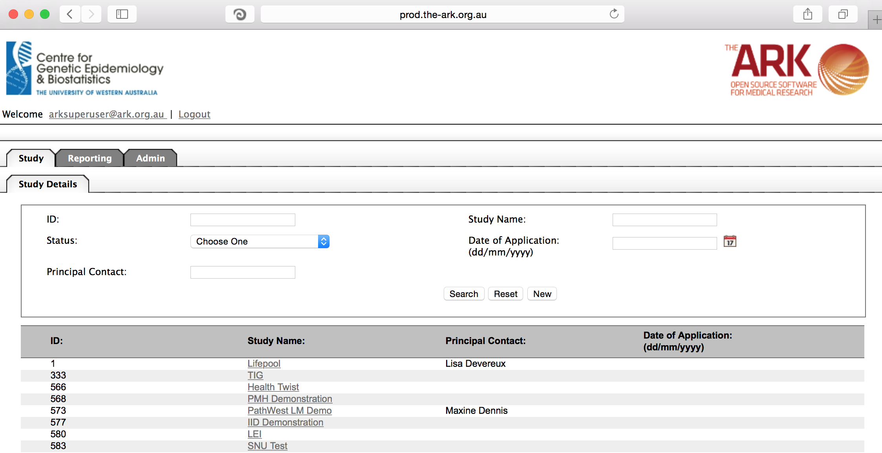

Alternatively if you have a very long list of studies under your management you may use the search pallette/panel at the top of the page. You can search/filter by id, name, principal contact, status of the study or date of application. Once you have added your filtering criteria, click the search button;

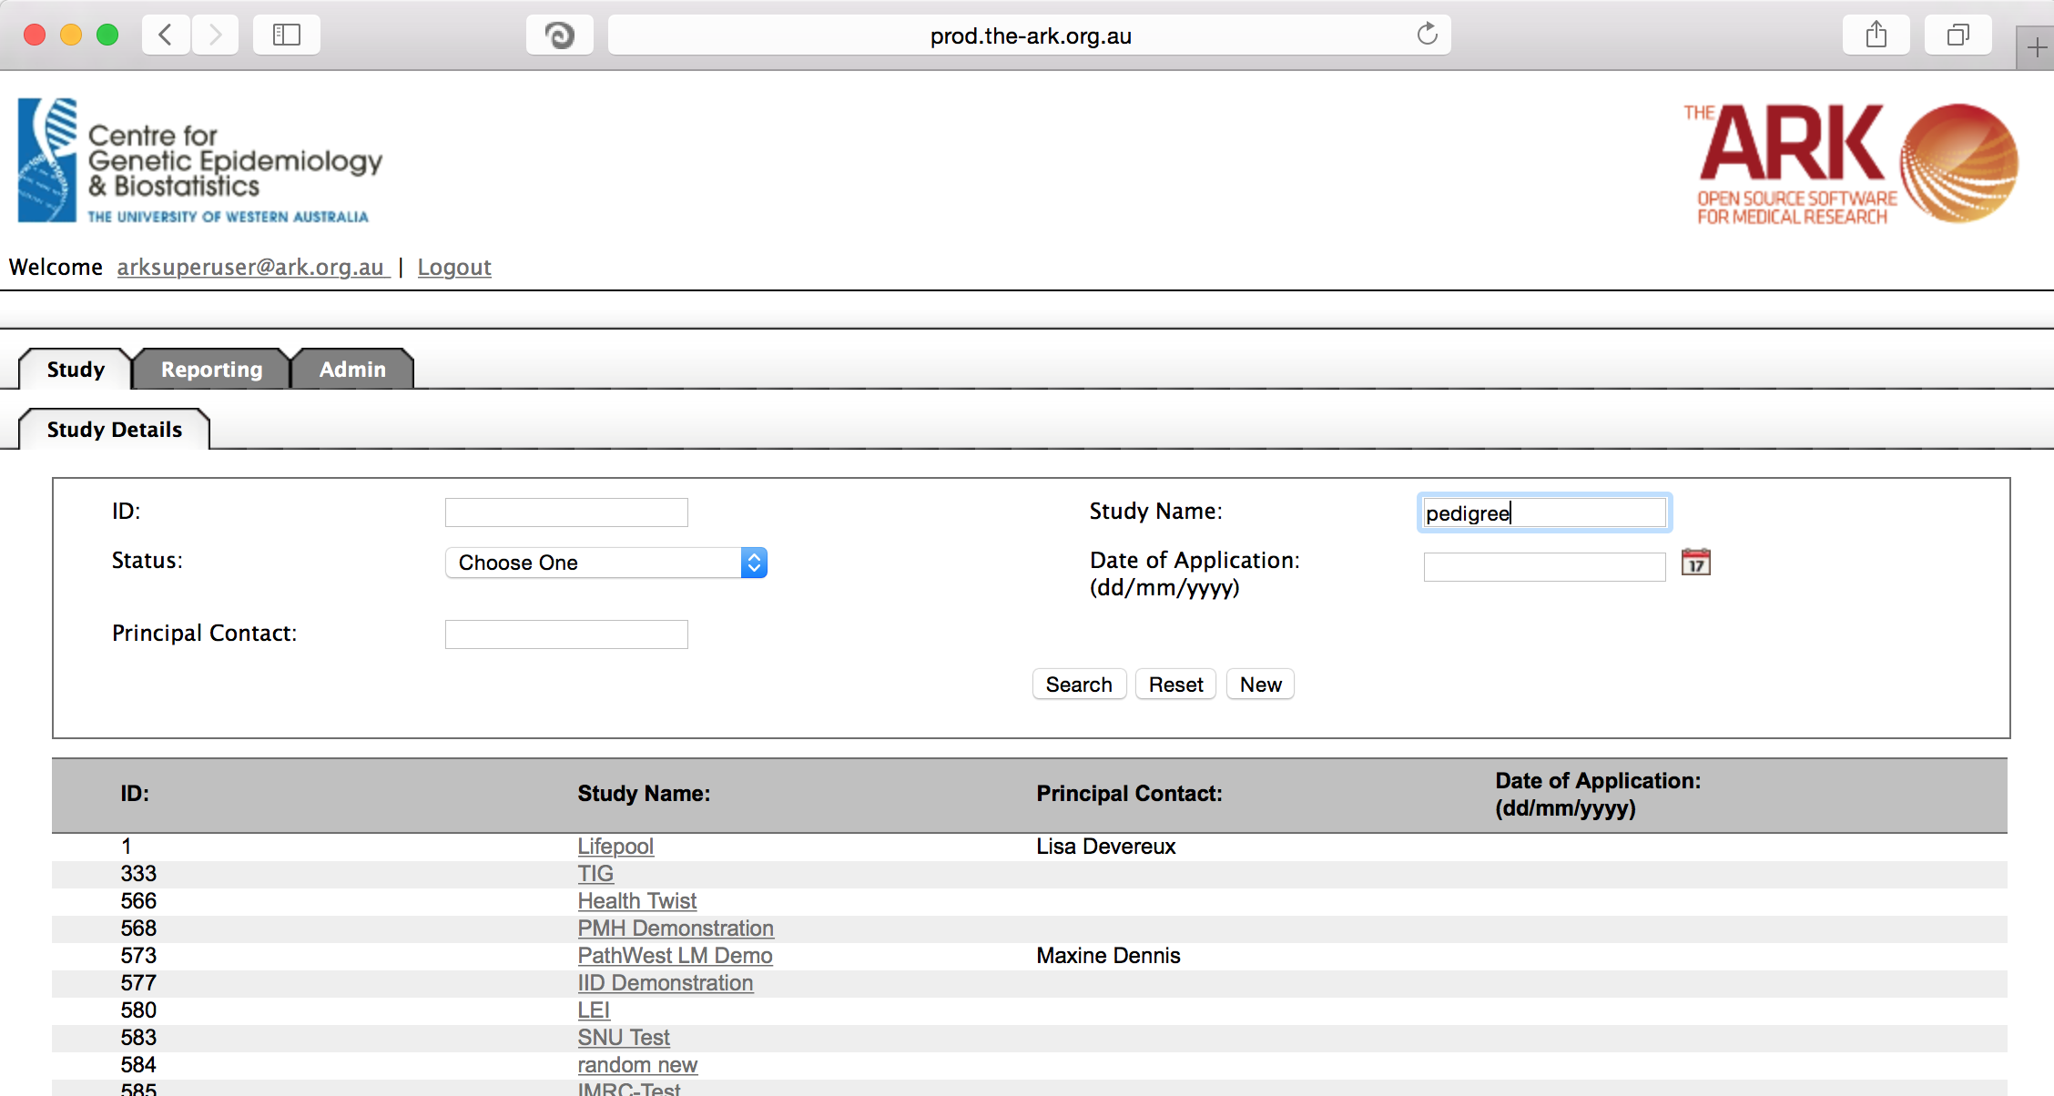

As you can see the filter has helped us find our chosen study and we can click the hyperlinked study name as discussed before;

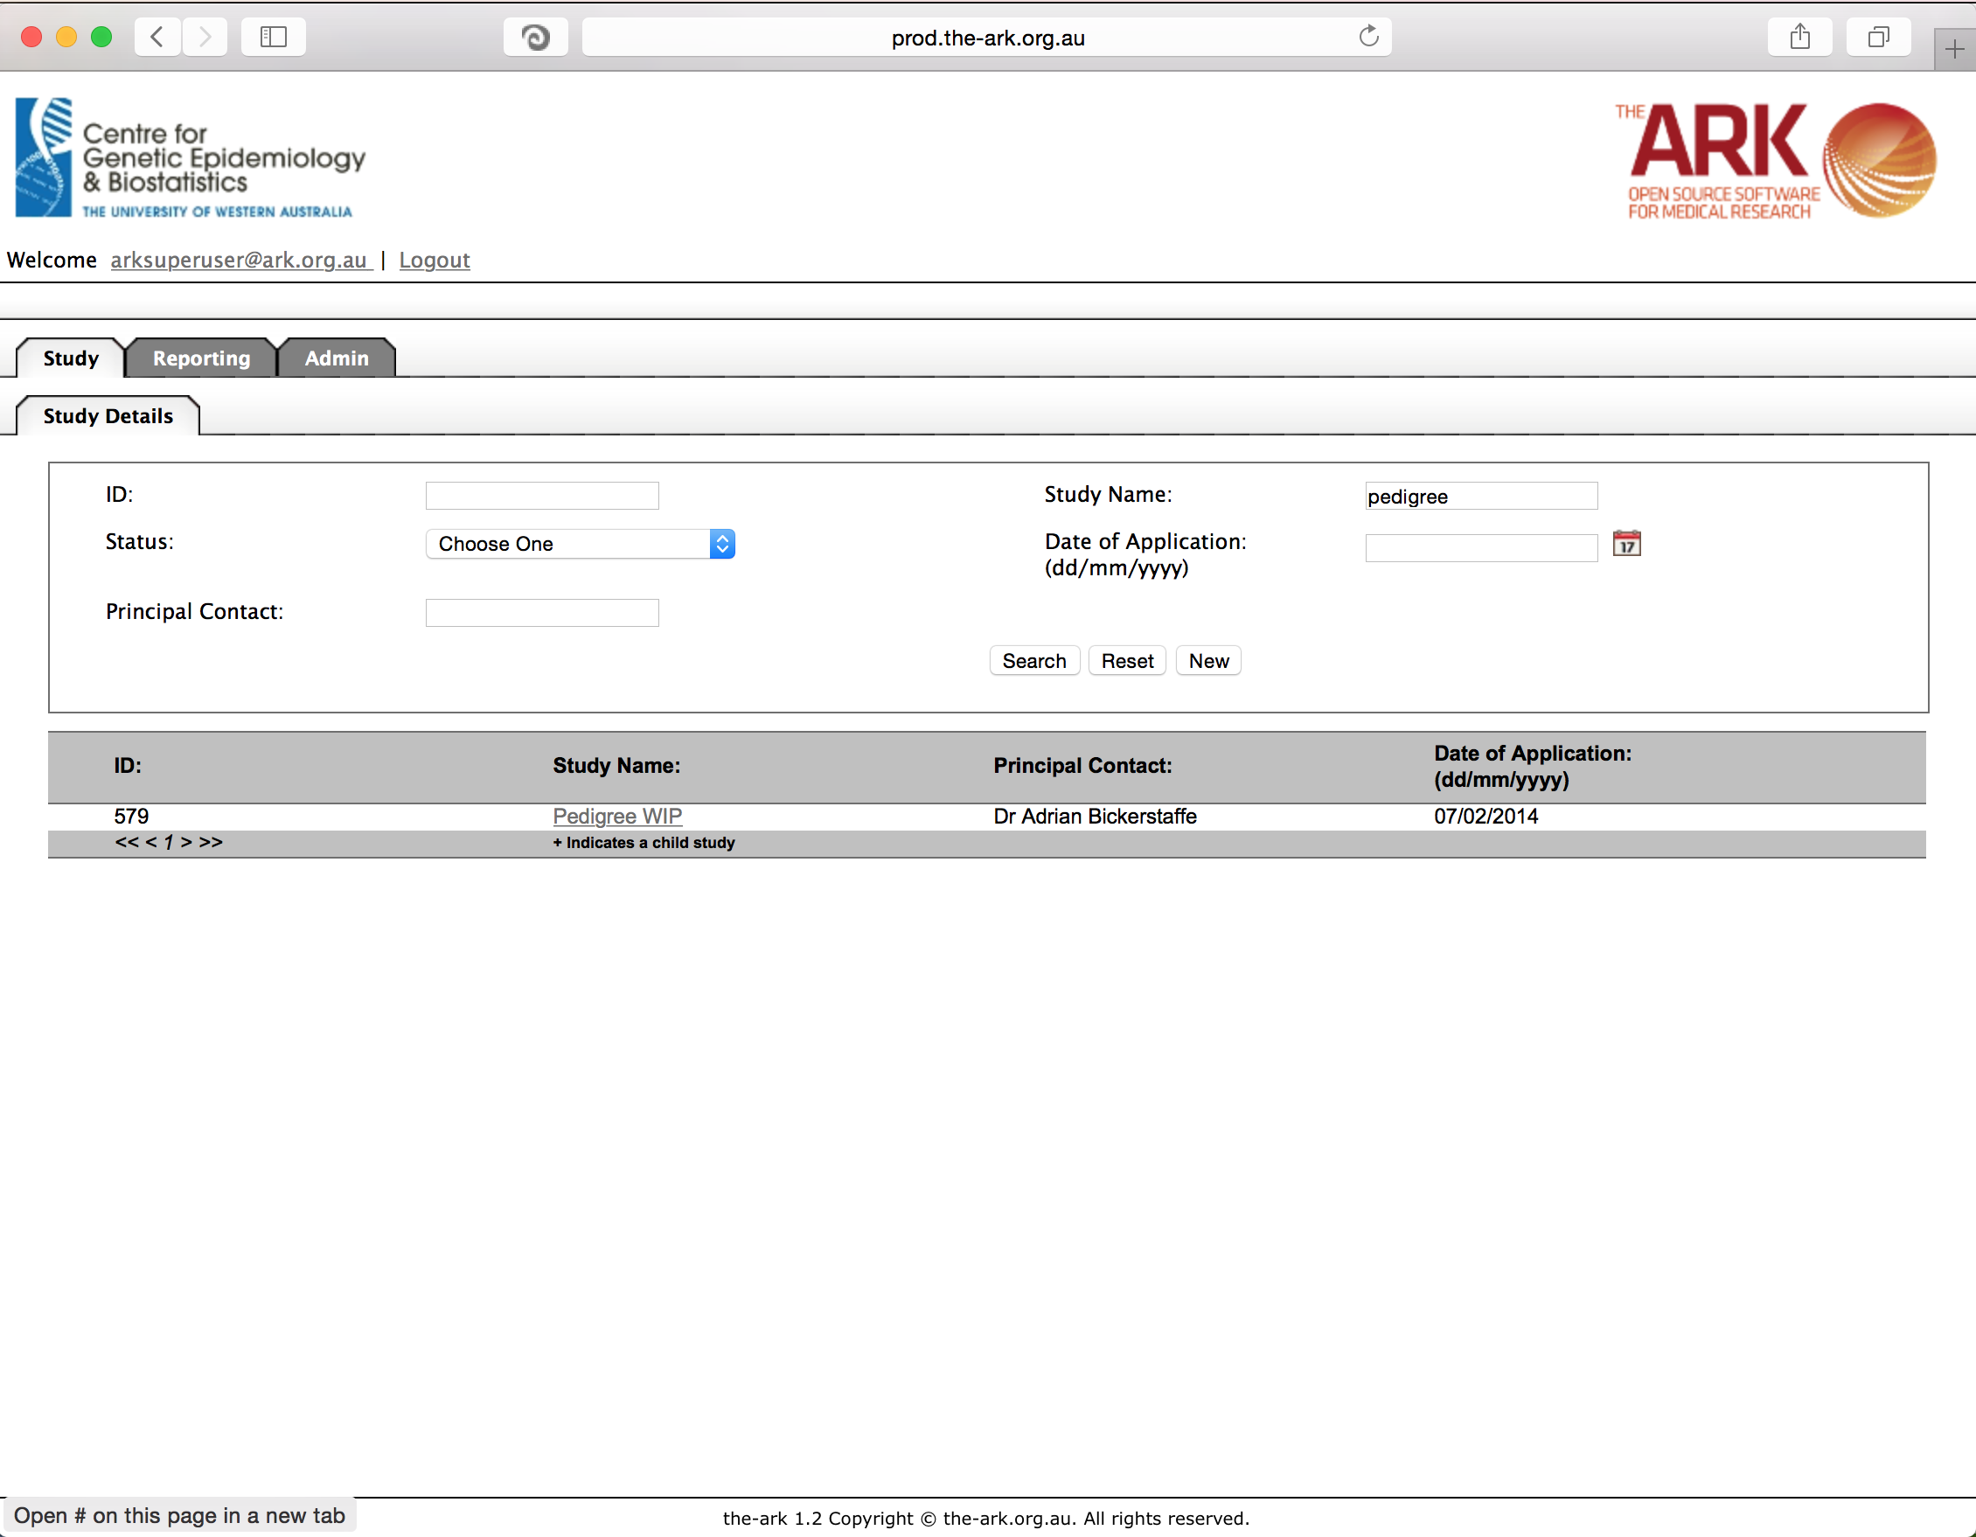

Once you have chosen your study we will be able to adjust study details or select modules and functions available in that study (for which you have privileges). The module we wish to select is Data Sets – then the function “Data Set Definition”.

The data dictionary is the list of longitudinal fields you have to choose from for longitudinal data. Some like to consider this phenotypic data fields, and some have referred to the collections of these fields as datasets or questionnaires. We basically have fields, which can be reused and sets of fields, which can be reused, and re-run over time (ie; longitudinal data).

Over previous Data Set documentation we have created, uploaded, updated the fields in our data dictionary. Now we want to create data sets, aka questionnaires, logical groupings of clinical data, which we may wish to ask once, or hundreds of times over the timeline of our study. This page is where we create those datasets, or (prior to their use) edit them. NOTE: Once a data set has data, it cannot be modified. If we wish to edit an existing data set, we can click on the hyperlinked name of said dataset.

For now we will create a new dataset. Click the “New” button.

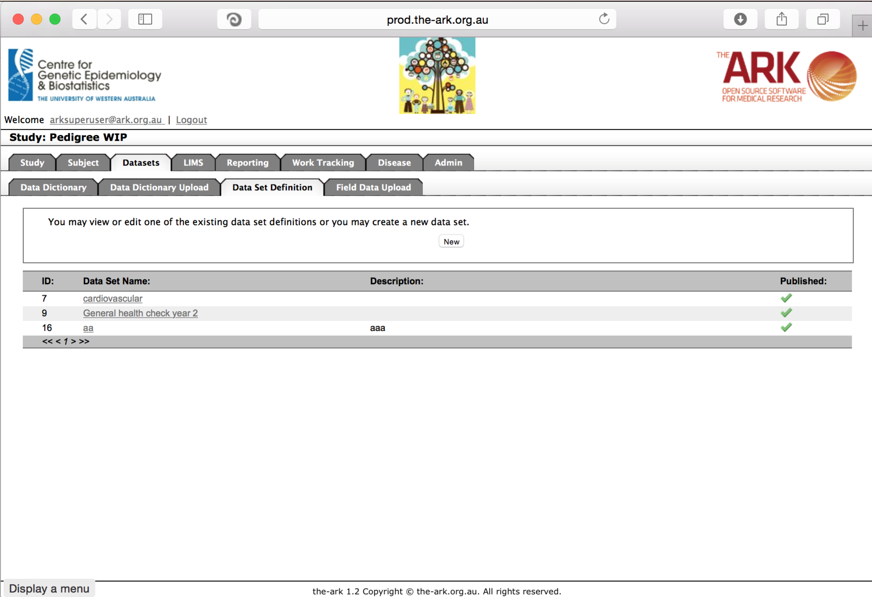

Most of these fields and options are similar to what we have seen before. We have a name which we want to meaningfully describe the data set. A description which we should put as much detail as possible.

The list of fields from our data dictionary can be selected from the custom fields selection box. For each field you want in your data set/questionnaire, put it in the selected column by double clicking from the other side, or make your selections and click the arrow to send it in the desired direction. You could also simply upload the names of all fields you want (one field per line) if you have an enormous or external list you wish to use.

The most important field to understand here though is the “published” check box. It is important to understand once the dataset is published, fields can no longer be added or removed in order to ensure the integrity and uniformity of the data set. If you do try to publish a dataset you do at least get a warning/reminder of this “**Custom Fields may not be added or removed once the Data Set is published.”**

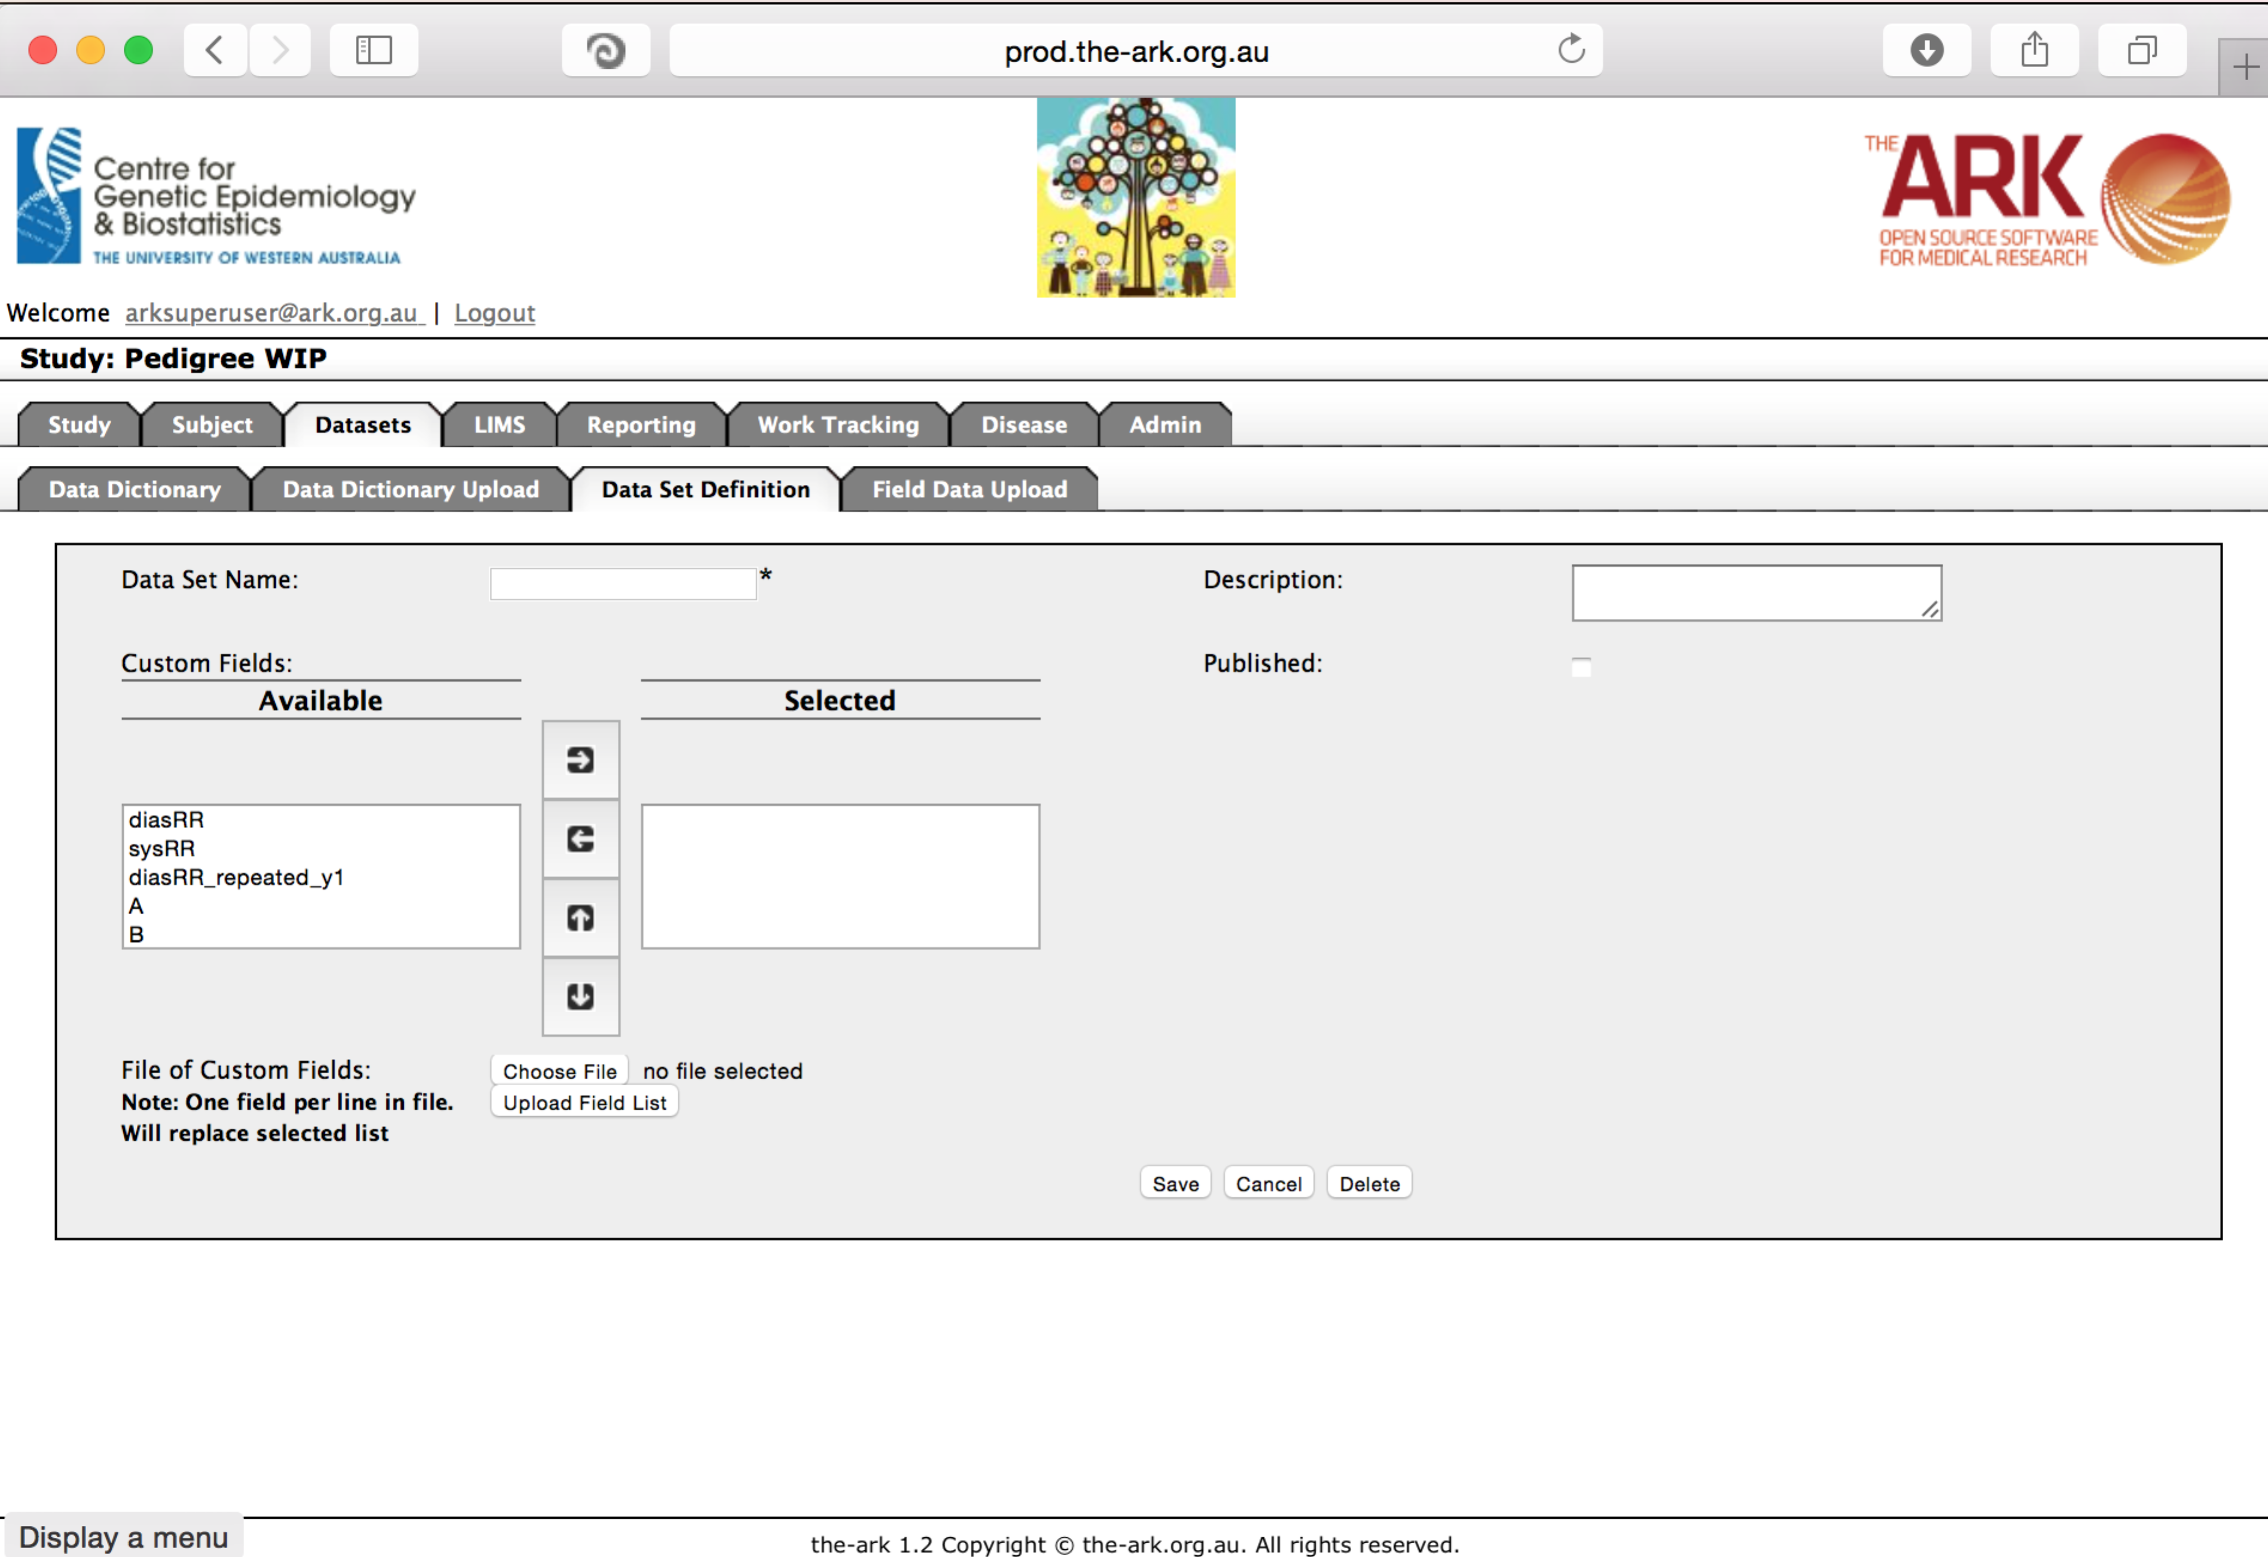

Ad you can see I have selected 6 fields for a cardiovascular questionnaire/data set. The green text at the top of the page tells me it was successful.

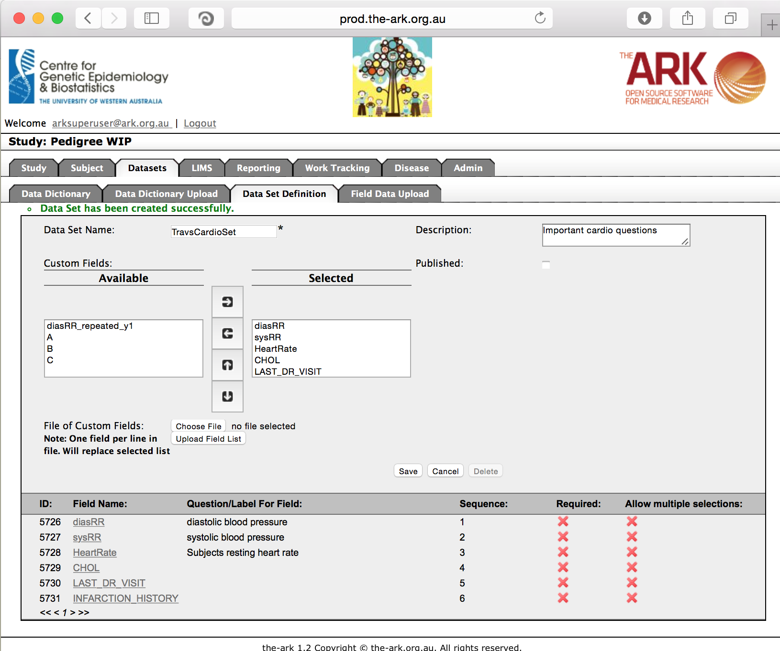Now that you have saved your questionnaire, you can adjust the various fields so say if they are required or not, as seen below

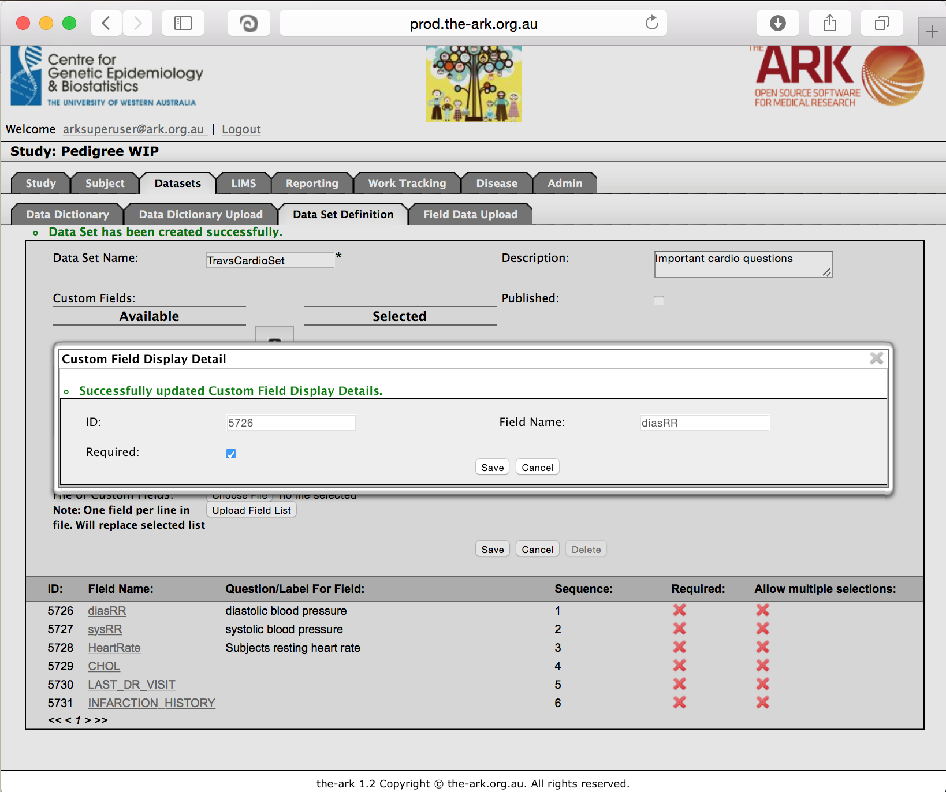

It is worth noting the update to the required flag is not uploaded live. This will eventually be fixed but for now, if you exit the panel and re-enter you can see the changes you made.

